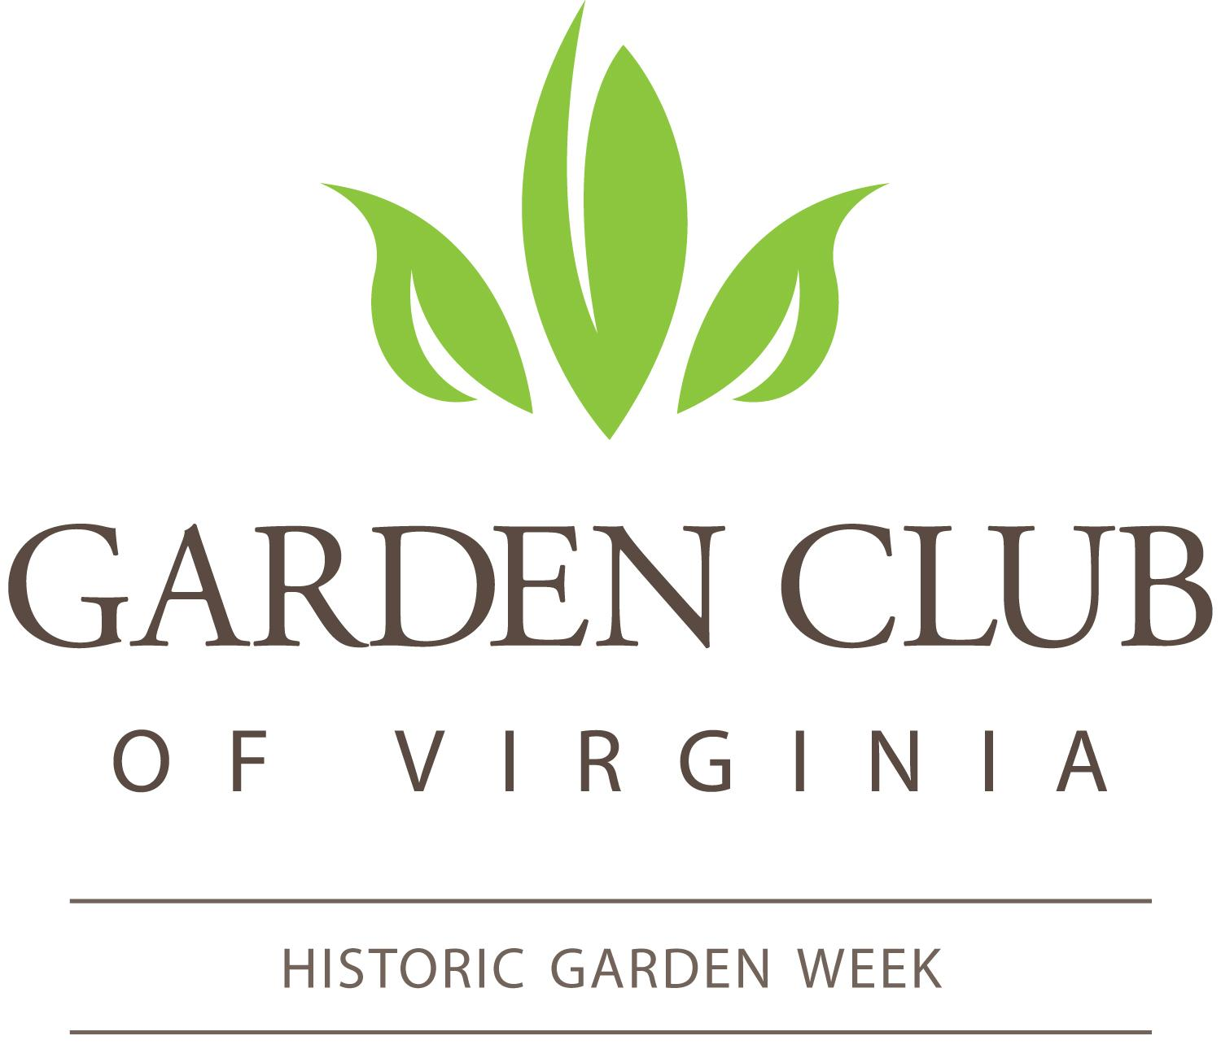

Master HGW 2024 Calendar for Tour Chairs and Co-Chairs
May 2023
● May 22 through 26 - Gmail and Google Drive onboarding with Terri
● May 31 - Final financial reports due for HGW 2023
June
● June 13 - Presidents Day
● June 14 - Boot Camp in-person at The Woman’s Club in Richmond
● June 30 - End of GCV’s fiscal year
July
● July 10 - The 100-word description of tours & Google Drive folder loaded with 2024 tour property photos due to Karen.
● July 10 - Committee contact lists: Advertising, Publicity/Marketing, Social Media, Guidebook Distribution and HGW Sign Chair due to Terri
August
● August 30 at 10:00 am - Design a HGW Budget ZOOM with Erma Baker, HGW and GCV Finance Committees
September
● September 12, 13 & 14 - Fall Region Meetings (North, South, East, West, Central)
● September 29 - Guidebook advertising deadline all due to Terri
October
● October 16 - Tour logistics for the Guidebook and Tour Descriptions due to Karen
● October 17 through 19 - GCV Board of Governors, Eastern Shore
- October 25 at 10:00 am Procurement for HGW with Virginia Gillock, HGW State Co-Chairman
November
● November 1 - Initial Guidebook Cover submissions for 2025 request due to Debbie Lewis, GCV President
● November 9 - HGW Marketing Meeting at The Woman’s Club in Richmond for Tour Chairs, Co-Chairs, Publicity/Marketing and Social Media Chairs from 10 am - 1 pm
● November 16 - Initial edits on tour logistics and tour descriptions for the Guidebook due to Karen
● November 23 - Thanksgiving
December
● December 1 - Statewide Guidebook distribution finalized by Terri.
● December 1 - Honor Roll of local sponsors for the Guidebook and the HGW website due to Terri
● December 1 - Guidebook layout and proofing by Region with Karen
● December 15 - Final proofing of all aspects of the Guidebook with Karen
● December 15 - January 1 - The Kent-Valentine House closed for the holidays.
January 2024
● January 10 - Guidebook goes to printing company, tentative date.
● January 15 - HGW tour signage request form due to Terri
● January 16- Deadline for 2025 Guidebook cover proposal submission
● January 23 - 2025 Guidebook cover will be selected at the HGW State Committee meeting.
● January 23 - Region Reps. will contact 2025 Tour Chairs
February
● February 13 - Tour Chair to review their online ticketing page for accuracy - no change requests after this date due to Terri.
● February 14 - HGW online ticketing goes live, and digital version of the Guidebook added to the HGW website Terri.
● February 20 - Guidebook starts to ship. Statewide distribution takes 2 weeks. March
● March 19 through 21 - Spring Region Meetings
April
● April 20 through 27 - 91st GCV’s Historic Garden Week
May
● May 6 - Zoom with Erma Baker, HGW Finance, and HGW Treasurers
● May 13 - HGW 2024 financial reports and tour attendance due to Karen
● May 21 through 23 - GCV Annual Meeting, Charlottesville
● May 24 - Deadline for 2024 Tour Chairs access to Gmail and Google Drive Terri
● May 28 through 30 - Onboarding of the 2025 Tour Chairs with Terri ● May 30 - Checks to GCV due June 2024
June
● June 11 - Presidents Day (tentative)
● June 12-13 - HGW 2025 Boot Camp
● June 30 - End of GCV’s fiscal year
July
● July 15 - The 100-word description of tours and photos due to Point of Contact Information:
Fran Carden, HGW State Chair 2022-2024
statechairman@vagardenweek.org
Virginia Gillock, HGW State Co-Chair 2024
statecochairman@vagardenweek.org
Karen Ellsworth, HGW Director and Editor of the Guidebook
karen@vagardenweek.org
Terri Lowman, HGW Marketing and Program Coordinator
terri@vagardenweek.org

Region Representatives:
Katie Harvard: northregion@vagardenweek.org

Sara Bugbee
southregion@vagardenweek.org

Melinda Morgan
eastregion@vagardenweek.org:

Robin Cherry westregion@vagardenweek.org

Patti Lynch
centralregionl@vagardenweek.org

